MAJOR PROJECT



**STATISTICAL SURVEY ON FINANCIAL DRAIN IN INDIA**

**INSTITUTE OF MATHEMATICAL SCIENCE AND COMPUTER APPLICATION**

**BUNDELKHAND UNIVESITY**

**JHANSI**



**BUNDELKHAND UNIVERSITY JHANSI**

**DEPARTMENT OF**

**INSTITUTE OF MATHEMATICAL SCIENCE**

**AND COMPUTER APPLICATIONS**

**SESSION : 2022 -2023**



**PROJECT FILE**

**STATISTICAL SURVEY ON FINANCIAL DRAIN IN INDIA**

( MAJOR PROJECT )

**Under the Supervision of**

**Dr. ANJALI SAXENA**

**Assistant professor**

**PREPARED BY**

**NAME-SUNEEL KUMAR**

**ROLL NO.-201181134059**

**COURSE- B.Sc (Hons.)(M/S/C)**

**SEMESTER- VIth semester**

**TABLEOFCONTENTS**

Pageno.

Certificate i

Certificateofapproval ii

Declaration iii

Acknowledgement iv

Abstract…………………………..…………………………………………… ....v

Listofchapters v

**CERTIFICATE**

This is to certify that **SUNEEL KUMAR** (Roll No.- 201181134059) has carried out the research work presented in this dissertation entitled **“Statistical Survey on FINANCIAL DRAIN IN INDIA ”** for the award of the degree of **B.Sc(Hons.) (Mathematics /Statistics / computer Science )**from Institute of Mathematical science and computer applications, Bundelkhand University, Jhansi under my supervision.

Signature of Guide:

**(Dr. ANJALI SAXENA)**

(Assistant professor) Date:

(Institute of Mathematical Science

and Computer Application,

Bundelkhand University, Jhansi)

**CERTIFICATEOFAPPROVAL**

Theproposedprojectreportentitled**“ STATISTICAL SURVEY ON FINANCIAL DRAIN IN INDIA”** beingsubmitted by **SUNEEL KUMAR**” hasbeenexaminedbyus and its hereby approved for the award ofthe degree “**B.Sc (Hons.) (Mathematics/ Statistics/Computer science)”**,forwhichithas been submitted.

It isunderstoodthat by thisapproval theundersigned donot necessarily endorse or approve any statement made,opinionexpressed or conclusion drawn therein ,but approvethe survey reportonly for the purpose for which it hasbeensubmitted.

(Internal Examiner) ( External Examiner )

Date- Date-

.

**DECLARATION**

Iamstudentof **B.Sc (Hons.) (Mathematics/ Statistics/ Computer science)** session 2022-2023, **BUNDELKHAND UNIVERSITY JHANSI (U.P.),**hereby declare thatthesurvey report entitled “**STATISTICAL SURVEY ON FINANCIAL DRAIN IN INDIA**”,over science stream student, is the outcome of my own work and that, to the best of myknowledge and belief, it contains no material previously written by anotherperson nor material which to a substaina extent has been accepted for theaward of any other diploma or degree of the university or other institute oflearning,where due acknowledgementhasbeenmadeinthe text.

Signatureofstudent

Place:Jhansi Suneel kumar

Date:

**ACKNOWLEDGEMENTS**

Every successful work is not completed without the help and support of thepeople around us. A success is shared by not an individual but in fact by thepeople who constantly help him and guide him in his work. Through this Iwanttoexpressmygratitudetowardsallthosewhohavedirectlyor indirectlycontributedinmyjourney.

It is my esteemed pleasure to present the survey report on **“Statistical survey on FINANCIAL DRAIN IN INDIA”.**

Iexpressmydeepgratitudetomyguide,**“Dr. Anjali Saxena”**,Assistant professor of department of mathematical science and computer application,who gavemetheinspiration to pursue the survey and guided me in this endeavor. He has beenaconstant sourceof motivationandencouragementforme.I thankhimforalltheinitiative andzealhefilleduswiththroughoutthe projectwork.

LastbutnottheleastIamvery thankfultomy teacher“ **Mr. PrabhatKarmarkar**” withouttheir supportatvariousstages ,thisprojectwouldn’thavematerialized.

I am really thankful to them. Secondly I would also like to thank my group members who helped me a lot in finishing this project within the limitedtime.

Iammakingthisprojectnotonlyformarksbuttoalsoincreasemyknowledge.

THANKSAGAINTOALL WHOHELPEDME

# 

# ABSTRACT

Four area of district Jhansi including university campus studentsparticipated in this survey of financial drain in India , using the online and offline survey to collect cross-comparable .This survey results report about the awareness of financial drain , prefer to use savings over loans and EMI and theirelements of knowledge, behaviour and attitudes. Patterns of product awareness and holding are reported as an illustration of financial inclusion. The main motive and target of the survey is to aware the people about the financial crisis and also tell them to stop lavishly expenditure by promoting long-term planning and saving, keepingcontrol over money, taking care with expenditure and avoiding financial fraud) and reports on a novel scoreof financial well-being.

Financial drain is a term that describes the continuous and often unnoticeable loss of money from one's budget over time. It is a common problem that can lead to significant financial strain if not managed appropriately. In this article, we will explore what causes financial drain and provide some tips on how to avoid it.

Right investment, savings and right way to use money can only help them in their difficult time. As we have seen in past year at the time of COVID panademic in 2020 , so many people suffer from the financial crisis because of lack of financial knowledge they were unable to feed themselves but on the other hand the people who have the knowledge of investment, savings and know where to expand money, get some relief at that time.

The methodology used in this work include subheadings like research decision, sampling procedure, data collection and method of data analysis as well as statistical tool of analysis.

The method of research design that was adopted in this study is the sample survey. To collect the sample we apply stratified random sampling .We have used chi-square to test our hypothesis. We discovered that the tabular value is less than our calculated value.  
We reject the null hypothesis “there is significant relationship between variables.” here our main targeted variable is SAVINGS

In the last we get that approx. people are not aware about the financial drain and only people use savings at the time of need

# ListofChapters:-

**CHAPTER TOPICS PAGENO.**

CHAPTER1 INTRODUCTION 10- 13

Introduction to financial Drain

Early drain of wealth

DadabhaiNaoroji’s theory of drain of wealth

Necessity of savings

CHAPTER2 OBJECTIVE OF THE STUDY 14-15

Objective

Concept of finance

Purpose of study

Review of study

CHAPTER3METHODOLOGY & QUESTIONNAIRE 16- 19

Methodology

Google form view

Questionnaire for the survey

CHAPTER4DATA COLLECTION AND CLEANING 20-22

Data collection

Cleaning of raw data

Data uploading from excel to SPSS

CHAPTER5DETERMINITATION OF SAMPLE SIZE 23-26

AND TECHNIQUE

Sampling methods

Stratified random sampling

Proportionate stratified random sampling

Advantages of stratified random sampling

Disadvantages of stratified random sampling

Sample size determination

CHAPTER6 STATISTICAL TEST AND HYPOTHESIS 27

Fisher’s exact test

Hypothesis

CHAPTER7DATA TABULATION AND INTERPRETATION28-55

Data tabulation and graphs

Testing of Hypothesis

Summary report

CHAPTER8 RESULT AND COCLUSION 56-58

* 1. Result
  2. Conclusion
  3. Reference

**CHAPTER–1**

**INTRODUCTION**

**INTRODUCTION TO FINANCIAL DRAIN-**

Financial drain is a term that describes the continuous and often unnoticeable loss of money from one's budget over time. It is a common problem that can lead to significant financial strain if not managed appropriately. As we can see that people start to spent their money in parties ,unused materials, and became extravagant and even they don’t have any knowledge how their money is draining day by day. This may cause a very vital effect on our next generation as they don’t have any awareness and idea about how to invest properly and how to save money. It is noticed that the new upcoming generation spend money lavishly. Pump and show is the trend of the day. That is why our youth are bent on this habit and they are becoming extravagant. It is also a reason that people who are introverts to express their inner pressure become extroverted.

Spending and debt accumulation amongst the country's young is a cause for concern. The long-term effects of this can be disastrous.

Understanding financial management and living on a budget is the key. While the figures revealed are startling they could be the tip of the iceberg. The youth must shun their obsession to live a luxurious lifestyle and adopt a tone of practicality. This will help them to be free from debt, given that a significant percentage currently avails of loans just to make a lavish purchase in the absence of proper cash flow.

Lack of parental guidance has been cited as the driving force behind the Emirati youth's materialism and disregard for debt accumulation. Coupled with that is a society driven by consumer culture. Youth must realise that there are two absolute realities: life and debt. They must be free of the latter.

**Early Drain of Wealth**

After the battle of Plassey, the drain of wealth took an outward turn as England gradually captured monopolistic control over the Indian economy. This allowed them to drain wealth from India, which they would then use to finance their own growth. Company employees gained political power, and the Company itself acquired a privileged status, which allowed them to acquire wealth through traditional ways of trade in India.

The Company’s employees earned large incomes through their participation in internal trade. At the same time, British Free Merchants earned a great fortune through their private trade. The drain of wealth theory was interpreted as an indirect tribute that imperial Britain extracted from India. The practice continued for many years after the prohibition imposed by the Court of Directors in 1766.

**DadabhaiNaoroji’s Theory of the Drain of Wealth**

DadabhaiNaoroji was an early pioneer in the study of colonialism and poverty. He was convinced that the main reason behind poverty was the colonial rule that was draining the wealth and prosperity of India. The drain of wealth was the portion of India’s wealth and economy that foreigners captured.

DadabhaiNaoroji propounded the Drain of Wealth theory in 1867. Many researchers have further analysed and developed it, including R.P. Dutt and MG Ranade. In 1867, DadabhaiNaoroji proposed what is known as the ‘economic imperialism’ theory, in which he stated that British economic policies were completely draining India. He mentioned this theory in his book, Poverty and Un-British Rule in India, and it is also known as the ‘Drain Theory’.

He criticised that out of the revenues raised in India, approximately one-fourth of the money which is raised in India goes to England, which is the main cause of India’s poverty.

**Causes of Financial Drain-**

There are many causes of financial drain, and they can vary from person to person. Here are some of the most common:

* Subscriptions and Memberships:

One of the most significant causes of financial drain is subscriptions and memberships. These are often automatically renewed, and people forget to cancel them when they are no longer using them.

* Eating Out:

Eating out can be a major cause of financial drain. People tend to underestimate how much they spend on food outside the home. A simple meal at a restaurant can easily cost three times as much as cooking the same meal at home.

* Impulse Buying:

Impulse buying is another significant cause of financial drain. People tend to buy things they don't need or didn't plan to buy, often because they are on sale or because they think they will make them happy.

* Credit Card Debt:

Credit card debt can be a significant cause of financial drain, especially if you only make Savings are generally made by putting aside cash in a savings account in a bank and this amount can be used in times of emergencies or to attain a short-term goal. In fact, saving money is one of the most undisputed rules of planning a steady financial life. Saving money helps you build wealth and also have funds to face financial crisis. Learning how to save money is a life lesson which everyone must master.

**NECESSITY OF SAVINGS**

People save money for a variety of reasons as it provides financial security and freedom and also secures you in case any financial emergency arises. One can avoid debt, pay off loans, live their dream life and avoid further debt if they have saved a sufficient amount (which differs from each individual to other). The importance of savings cannot be denied, owing to the multiple benefits that it offers.

Savings are generally made by consuming less today so that one is able to consume more in the future. The importance of saving money has to be understood in depth because savings enable individuals to not be completely dependent on their monthly salary to sustain their current lifestyle and also to plan for their long term financial security.

Truthfully, there are several reasons why one must start savings as early as possible.

1. Long-Term Security

The future is uncertain and this signifies the importance of saving money even more. Savings bring along long-term security and it is said that the more you save, the more secure you will be. Without savings, one cannot handle the financial storms or emergencies that come during a lifetime. Also, with savings, one can think of various avenues of investments which can generate profits for them and from those profits, individuals can surely ensure long-term security.

2. Savings is a Step towardsattaining Financial Freedom

Imagine giving yourself the freedom to do what you want, spend on what you desire and make more room for relaxation in your life! Well, all of this is possible with savings and thus the importance of saving money gains manifold importance. Without savings, one can feel stuck in a particular situation, if they highly rely on a pay check, but with savings, the scenario is totally different as funds for emergencies and contingencies are set aside.

3. Saving Money allows you to take Calculated Risks

If you set a savings goal and contribute regularly to your savings each month or at frequent intervals, you can explore a whole new range of opportunities. For example- trading in the stock market, starting a new business, funding an NGO etc. Thus, savings enable you to take calculated risks without relying heavily on a pay check. In other words, it allows you to have a greater sense of financial security and take calculated risks with the amount you have saved.

4. Savings Reduce Stress

Savings are surely one of the most important factors in leading a stress-free life. Knowing that you have gathered a certain amount of fund gives you a sense of relief and peace of mind. By saving money in a disciplined manner, your long-term and short-term goals can be achieved, you can plan your children’s education, take more care of your family, fund big purchases, prepare for unfortunate events and overcome most financial difficulties. Thus, one must be convinced that saving money is a primary goal that everyone must seek.

5. Savings allows to take benefits of compound interest

Among the various benefits of savings, one of the biggest benefits is that it allows individuals to utilise the power of compound interest. Thus, if you start saving now and invest it in the right avenues, you can start seeing impressive results. Compound interest takestime to show its magic. Hence, one needs to give time to savings and see them grow over time. In fact, with the power of compounding, people have created wealth and this intensifies the importance of savings.he minimum payment each month. The interest charges can quickly add up, making it difficult to pay off the balance.

Financial drain can be a significant problem, but it is avoidable with the right strategies. By reviewing your expenses, cooking at home, sticking to a budget, and paying off credit card debt, you can avoid the continuous loss of money from your budget over time. Remember that every dollar saved is a dollar earned, so take steps today to avoid financial drain and improve your financial future.

**CHAPTER – 2**

**OBJECTIVE OF THE STUDY**

**OBJECTIVE**

The main objective the study to aware the people about the financial crisis and how savings help them to improve their financial condition

**Concept of finance**

The term ‘finance’ is derived from economics. We know the basic notion of economics is that the wants are unlimited, but the resources are limited. How an individual, a business, business, or society fulfills unlimited needs using the limited resources available is a fundamental principle of economics.

In the context of business, finance refers to cash, banks, loans, investments, forecasting, borrowing, budgeting, saving, and many other aspects that are directly or indirectly related to money.

Finance is the lifeblood of business without which a business cannot function. Finance plays a critical role from the beginning of a business.

**Purpose of study**

**Goal 1: To develop a broad understanding of financial concepts and tools through:**

Objective 1.1: Knowledge of financial theories within the primary areas of finance;

Objective 1.2: Utilization of problem solving skills within the finance setting;

Objective 1.3: Application of financial analysis tools and techniques to decision making;

Objective 1.4: Consideration of the effect of global influences on the financial decision making process.

**Goal 2: Effectively communicate financial information:**

Objective 2.1: Orally, by being able to present, discuss, and defend financial decisions by using appropriate terminology;

Objective 2.2: By being able to write reports containing appropriate terminology;

Objective 2.3: To finance professionals through the development of interpersonal and teamwork skills.

**Goal 3: Increased awareness of ethics and social responsibility in the context of finance by:**

Objective 3.1: The ability to identify ethical dilemmas within the finance setting;

Objective 3.2: The ability to identify, evaluate and select alternative courses of action for addressing the ethical dilemma;

Objective 3.3: An appreciation for socially responsible actions with respect to financial decisions.

**REVIEW OF THE STUDY-**

The review focuses on:

■ people of working age – although much of the evidence reviewed covered adults of all ages;

■ People on low to middle incomes

■ adult cash savings (rather than investments or saving for children); and

■ community-based interventions.

The evidence included in the review focuses specifically on interventions that promote savings behaviours; it does not cover in any detail wider issues around financial inclusion and borrowing.

**CHAPTER – 3**

**METHODOLOGY AND QUESTIONNAIRE**

**Methodology**

The methodology consists of a conceptual discussion on highlighting the behavior of savings in comparison to borrowing, taking loans etc. This survey highlights the nature of extravagant people who don’t know to use their money in a proper manner.

Over the population of 59346 people of four locality the data of approx. 2400 people is collected by offline and online mode survey. The selection of the respondant is based on Proportionate stratified random sampling.

An offline survey and an online survey is conducted over Google Form in four loacalities of Jhansi district. Response of each participant is collected using linked survey and responses were automatically generated and recorded. The data collected in offline survey are entered through data entry in Excel. The survey is equally responded by every age group people contributing almost equally. The survey was disconnected in four month time. The questionnaire includes fifteen questions covering age criteria , members in household , income and about the use of credit card and investments according to the need and was applied on a sample consisting of 2400 participants which in turn reflects major population of Jhansi District. The period of application of the questionnaire isMarch 3rd to 11thjuly,2023.

A total of 127 participants completed the questionnaire data on "Financial Drain in India”and theleft over data is collected through offline mode .

A survey questionnaire is administered uniformly on a sample of 2400 participants. Participants are assured that their information would be used only for research purpose. There were no right and wrong responses.

After collecting the data, the percentage of each response was calculated.

When the all responses is collected we follow the procedure to get the result-

* First of all we enter all data in a excel sheet which is formed as raw data.
* In second step we clean the data by removing unwanted variables like name , email etc.
* When the data is cleaned we replace the statements with variables which are strings, numeric.
* After it we analyze data and apply exact and get the p value of sample.
* Then we set the hypothesis to find out the association between the variables

**GOOGLE FORM VIEW– FIG 3.1**

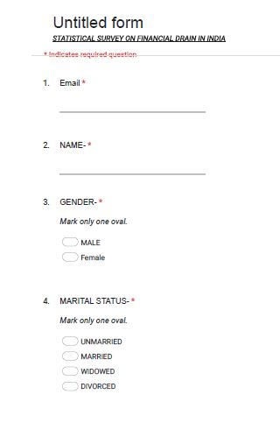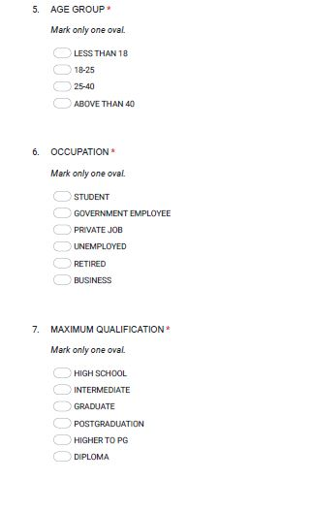

**Link to google form**

https://docs.google.com/forms/d/e/1FAIpQLSeTh9o85PkDEtjZE0Uarf96RxU5nIKf2einQy2AKGANv5v-dA/viewform?usp=sf_link

**QUESTIONNAIRE FOR THE SURVEY -**

**The questionnaire is made in both Hindi and English format to get the better responses from each person according to their comfort zone.**



**“ STATISTICAL SURVEY ON FINANCIAL DRAIN IN INDIA ”**

Name- .

Gender - Male Female

Marital status – Unmarried Married Widowed Divorced

Age Group – Less than 18 18-25 25-40 Above than 40

Occupation - Student Private Job Unemployed Retired Business Government employee

Maximum Qualification – High school Intermediate Graduate Diploma Postgraduation Higher to PG

Monthly income - Less than 10K 10K-20K 20K-50K Above than 50K

1. Are you the head of the household.

Yes

No

1. If no then your relation with household head-

Spouse

Father or Mother

Child

Brother or Sister

1. How many members are there in your household-

Less than 4

4 – 7

More than 7

1. Do you have credit cards? This would include VISA, Master card, American express, Dinner club/ En route or retail store cards.

Yes

No

1. If you had to make an unexpected expenditure today of 5000Rs or more would you-

Use savings

Borrow from friends or relatives

Borrow from financial institution

1. Excluding any money spent on investments or the purchase of a home would you say that you are spending lavishly (unwanted purchase)-

Exceeded income

Equal to income

Less than income

1. Do you ever invest in insurance policies or any saving schemes?

Yes

No

1. Do you (or any family member) owe any money education loans for higher education/ professional education?

Yes

No

1. In which type of course/ college you take an education loan-

Government college(UG/PG)

Private college (UG/PG)

Specialized training courses

Certified course like in computer, data science, job oriented course etc.

1. Do you and your family have any life insurance policies? Including term, permanent, mortgage and group insurance.

Yes

No

1. Do you think thatyou are an extravagant?

Yes

No

1. Do you ever have any loan or purchased anything on EMI?

Yes

No

1. If yes then in which field you have taken any loan or EMI

Education

Property/Home

E-marketing / Mobile

Vehicles

1. Do you have any awareness about financial drain facing nowadays in our country?

Yes

Nobh

1. Do you prefer to take loan/ EMI over savings?

Yes

No

If there any suggestions you want to provide___________________________________________________ __________________________________________________________________________________________________________________________________________________________________________________________________________

**“भारत मे व्यापत वित्तिय गिरावट पर सर्वेक्षण ”**



**सामान्य जानकारी -**

नाम- .

लिंग - पुल्लिंगस्त्रीलिंग

वैवाहिक स्थिति – अविवाहित विवाहित वैध्व्य तलाकशुदा

आयु – 18 से कम 18-25 25-40 40 से अधिक

व्यवसाय - विद्यार्थी प्राइवेट नौकरीबेरोजगारसेवानिवृत निजी व्यवसाय सरकारी नौकरी

अधिकतम योग्यता – हाई स्कूल इण्टरमीडिएट स्नातक डिप्लोमा स्नातकोत्तर स्नातकोत्तर से अधिक

मासिक आय – 10 से कम 10,000 – 20,000 20,000-50,000 50,000 से अधिक

1. क्याआपघरकेमुखियाहैं?हॉनही
2. यदिनहीतोघरकेमुखियाकेसाथआपकासम्बन्ध-पत्नी/पतिमातायापितापुत्र/पुत्रीभाई/बहन
3. आपकेघरमेकितनेसदस्यहैं?4 सेकम 4-7 7 सेअधिक
4. क्याआपकेपासक्रेडिटकार्डहैं? इसमेंVISA, Master card, American express, Dinner club/ En route or retail store कार्डसशामिलहोंगे।

हॉनही

1. अगरआपकोआज 5000 रुपयेयाउससेअधिककाअप्रत्याशितव्ययकरनापडेतोआपक्याकरेंगे-बचतकाप्रयोगकरेंगेवित्तीयसंस्थानोसेउधारलेंगेमित्रोंयारिश्तेदारोंसेउधारलेंगे
2. निवेशयाघरकीखरीदपरखर्चकिएगएकिसीभीपैसेकोछोद्करक्याआपकहेंगेकिआपअत्याधिकखर्चकररहेहैं (अवांछितखरीद)आयसेअधिकआयसेकमआयकेबराबर
3. क्याआपनेकभीबीमापॉलिसियोंयाकिसीबचतयोजनाओंमेनिवेशकियाहै?

हॉनही

1. क्याआप (यापरिवारकेकिसीसदस्य) परउच्चशिक्षा/व्यवसायिकशिक्षाकेलिएशिक्षाऋणलियाहै?हॉनही
2. यदिहॉतोआपनेकिसतरहकेकोर्स/ कॉलेजमेंएजुकेशनलोनलियाहै-सरकारीकॉलेजप्राइवेटकॉलेजविशेषप्रशिक्षणपाठ्यक्रमप्रमाणितपाठ्यक्रम( कम्प्यूटर, टैलीइत्यादि)
3. क्याआपकेऔरआपकेपरिवारकेपासकोईजीवनबीमापॉलिसीहै? टर्म , स्थायी, बंधकऔरसमूहबीमासहित।हॉनही
4. क्याआपकोलगताहैकिआपफिजूलखर्चीकरतेहैंहॉनही
5. क्याआपनेकभीकोईऋणलियाहैयापरकुछखरीदाहैहॉनही
6. यदिहॉंतोआपनेकिसक्षेत्रमेंकोईलोनयालीहै

शिक्षासम्पत्ति/घरई-मार्केटिंग/मोबाइलवाहन

1. क्याआपकोजानकारीहैकिहमारादेशआजकलवित्तीयगिरावटकासामनाकररहाहै-हॉनही
2. क्याआपबचतकेस्थानपरऋण/ लेनापसन्दकरतेहैं ?हॉनही

क्याआपकोईसुझावप्रदानकरनाचाहतेहैं

**CHAPTER-4**

**DATA COLLECTION AND DATA CLEANING**

**DATA COLLECTION-**

Data is collected through the Google form explore sheet in excel-

**RAW DATA –FIG 4.1**

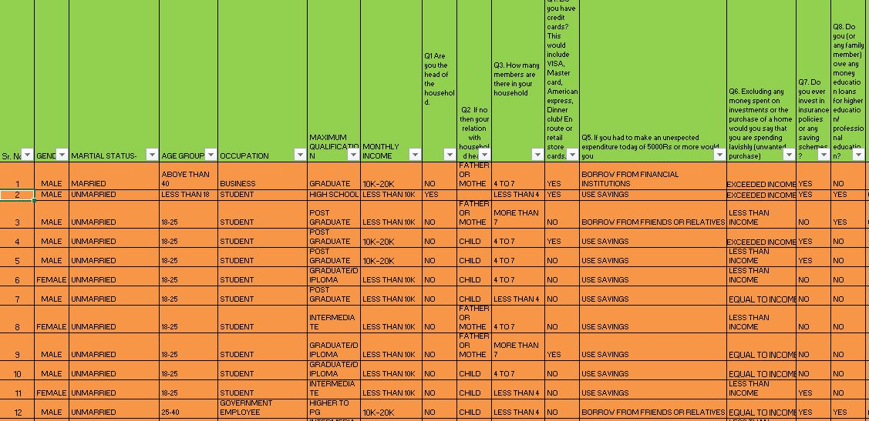

**CLEANING OF RAW DATA**

TOOLS USED FOR CLEANING-

* FILTER `~ FIG ~4.2

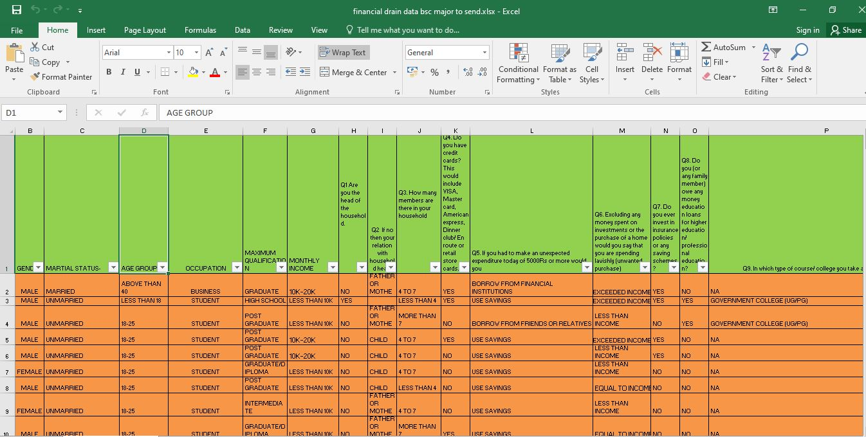

* FIND AND REPLACE ~ FIG 4.3

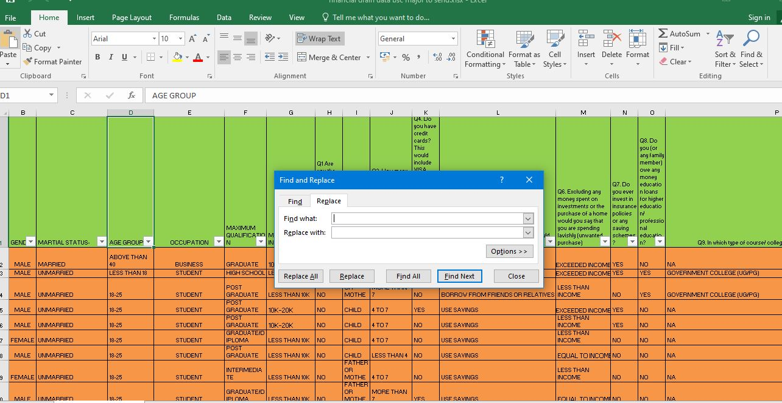

DATA UPLOADING FROM EXCEL TO SPSS- FIG ~4.4

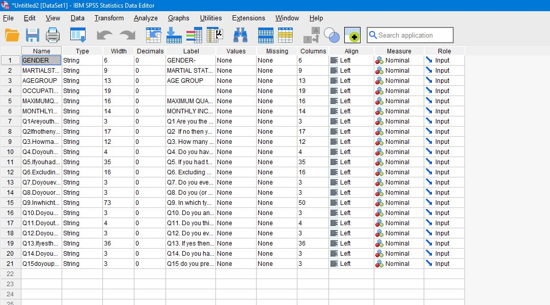

**CHAPTER – 5**

**DETERMINATION OF SAMPLE SIZE AND TECHNIQUE**

**Sampling Methods**

Sampling is a technique of selecting individual members or a subset of the population to make statistical inferences from them and estimate the characteristics of the whole population.

Sampling is an essential part of any research project. The right sampling method can make or break the validity of your research, and it’s essential to choose the right method for your specific question.

**What is Stratified Random Sampling?**

Stratified random sampling is a type of probability method using which a research organization can branch off the entire population into multiple non-overlapping, homogeneous groups (strata) and randomly choose final members from the various strata for research which reduces cost and improves efficiency. Members in each of these groups should be distinct so that every member of all groups gets an equal opportunity to be selected using simple probability. This sampling method is also called “random quota sampling.”

**Proportionate Stratified random Sampling:**

|  |
| --- |
| Proportionate Stratified Random Sampling Formula: nh = ( Nh / N ) * n |

In this approach, each stratum [sample size](https://www.questionpro.com/blog/determining-sample-size/) is directly proportional to the population size of the entire population of strata. That means each strata [sample](https://www.questionpro.com/blog/what-is-online-research-sample/) has the same sampling fraction.

**nh**= Sample size for hth stratum

**Nh**= Population size for hth stratum

**N** = Size of entire population

**n** = Size of entire sample

**Advantages of stratified random sampling**

Stratified random sampling gives you a systematic way of gaining a population sample that takes into account the [demographic](https://www.qualtrics.com/au/experience-management/brand/demographic-segmentation/) make-up of the population, which leads to stronger research results.

The method is fair for participants as the sample from each stratum can be randomly selected, meaning there is no bias in the process.

As participant grouping must be exhaustive and mutually exclusive, stratified random sampling removes variation and the chances of overlap between each stratum.

Lastly, it helps with efficient and accurate data collection. Having a smaller, more relevant sample to work with means a more manageable and affordable [research project](https://www.qualtrics.com/blog/research-problem/).

**Disadvantages of stratified random sampling**

Researchers may hold prior knowledge of the population’s shared characteristics beforehand, which increases the risk for selection bias when strata are defined.

There is more administration to do to conduct this process, so researchers must include this extra time and order.

When randomly sampling each stratum, the resulting sample may not be representative of the full population. It is worth reviewing the results to see if the sample is proportional to the whole population.

Once you have the final sample, data analysis of the information becomes more complicated to take into account the layers of the stratum.

**1. Define the strata needed for your sample.**

Strata are usually created based on the differences between participant’s shared characteristics – e.g. their race, gender, nationality, level of education, or age group. Researchers may or may not already have prior knowledge about a population’s shared characteristics.

TABLE 5.1 STRATA FOR SAMPLE

|  |  |
| --- | --- |
| **AREA** | **POPULATION** |
| NAGRA | 20721 |
| SIPRI | 18873 |
| SADAR BAZAR | 5079 |
| SHIVAJI NAGAR | 14673 |
| **TOTAL** | **59346** |

**2. Define your sample size.**

It’s important to define the ratio numbers of your sample so it is proportionally representative of the total population (see the FAQ section below for more information).

|  |  |  |  |
| --- | --- | --- | --- |
| **AREA** | **POPULATION** | **PERCENTAGE** | **SAMPLE** |
| NAGRA | 20721 | 34.9% | 836.6 |
| SIPRI | 18873 | 31.8% | 762.2 |
| SADAR BAZAR | 5079 | 8.6% | 206.1 |
| SHIVAJI NAGAR | 14673 | 24.7% | 592.1 |
| **N= 59346** | **e= 0.02** | **100%** | **2397** |

Here N = total population

n= sample size

e= error (which is 2%)

**CHAPTER – 6**

**STATISTICAL TEST AND HYPOTHESIS**

**FISHER’S EXACT TEST**

Fisher’s Exact Test of Independence is a statistical test used when you have two nominal variables and want to find out if proportions for one nominal variable are different among values of the other nominal variable. For experiments with small numbers of participants (under around 1,000), Fisher’s is more accurate than the [chi-square](https://www.statisticshowto.com/probability-and-statistics/chi-square/) test or G-test.

Unlike other statistical tests, there isn’t a formula for Fisher’s. To get a result for this test, calculate the probability of getting the observed data using the null hypothesis that the proportions are the same for both sets.

Fisher’s Exact Test is used to determine whether or not there is a significant association between two categorical variables. It is typically used as an alternative to the [Chi-Square Test of Independence](https://www.statology.org/chi-square-test-of-independence/) when one or more of the cell counts in a 2×2 table is less than 5.

SET THE HYPOTHESIS-

Fisher’s Exact Test uses the following null and alternative hypotheses:

* H0: (null hypothesis) The two variables are independent.
* H1: (alternative hypothesis) The two variables are not independent.

We check the hypothesis at 5% significance level =0.05

* H0 (n>0.05) – There is no association between both variables
* H1(n<0.05) – Both variables are associated with each other

**CHAPTER – 7**

**DATA TABULATION AND INTERPRETATION**

**[Crosstab](https://www.qualtrics.com/au/experience-management/research/cross-tabulation/)**

[Crosstab (cross-tabulation)](https://www.qualtrics.com/au/experience-management/research/cross-tabulation/) is used in [quantitative market research](https://www.qualtrics.com/au/experience-management/research/quantitative-research/) to analyse categorical data – that is, variables that are different and mutually exclusive

Data tabulation and graphs

* THESE TABLE SHOWS THE CROSSTABS BETWEEN INDEPENDENT AND DEPENDENT VARIABLE

**HOW MANY PEOPLE USE SAVINGS**

* **TABLE 7.1 ON THE BASIS OF GENDER**

|  |  |  |  |
| --- | --- | --- | --- |
| **Count of GENDER-** | **Column Labels** |  |  |
| **Row Labels** | **FEMALE** | **MALE** | **Grand Total** |
| BORROW FROM FINANCIAL INSTITUTIONS | 529 | 360 | 889 |
| BORROW FROM FINANCIAL INSTITUTIONS | 7 | 17 | 24 |
| BORROW FROM FRIENDS OR RELATIVES | 112 | 103 | 215 |
| USE SAVINGS | 499 | 770 | 1269 |
| **Grand Total** | **1147** | **1250** | **2397** |
|  |  |  |  |

**\**From the above table it is observed that male prefer savings in comparison to female

**FIG ~7.1 ON THE BAIS OF GENDER**

.

* **TABLE 7.2 `ON THE BASIS OF MARITAL STATUS**

|  |  |  |  |  |  |
| --- | --- | --- | --- | --- | --- |
| **Count of MARTIAL STATUS-** | **Column Labels** |  |  |  |  |
| **Row Labels** | **DIVORCED** | **MARRIED** | **UNMARRIED** | **WIDOWED** | **Grand Total** |
| BORROW FROM FINANCIAL INSTITUTIONS |  | 701 | 175 | 13 | 889 |
| BORROW FROM FINANCIAL INSTITUTIONS | 1 | 4 | 1TABN9 |  | 24 |
| BORROW FROM FRIENDS OR RELATIVES |  | 95 | 117 | 3 | 215 |
| USE SAVINGS |  | 863 | 393 | 13 | 1269 |
| **Grand Total** | **1** | **1663** | **704** | **29** | **2397** |

From the above table it is observed married people prefer to use saving.

**FIG~ 7.2 ON THE BAASIS OF MARITAL STATUS**

* **TABLE 7.3 ~ON THE BASIS OF AGE GROUP**

|  |  |  |  |  |  |
| --- | --- | --- | --- | --- | --- |
| **Count of AGE GROUP** | **Column Labels** |  |  |  |  |
| **Row Labels** | **18-25** | **25-40** | **ABOVE THAN 40** | **LESS THAN 18** | **Grand Total** |
| BORROW FROM FINANCIAL INSTITUTIONS | 377 | 369 | 143 |  | 889 |
| BORROW FROM FINANCIAL INSTITUTIONS | 19 | 3 | 1 | 1 | 24 |
| BORROW FROM FRIENDS OR RELATIVES | 115 | 56 | 42 | 2 | 215 |
| USE SAVINGS | 696 | 180 | 383 | 10 | 1269 |
| **Grand Total** | **1207** | **608** | **569** | **13** | **2397** |

* **FIG 7.3 ~ON THE BASIS OF AGE GROUP**

**From the above table it is observed that the people between 18-25 age use savings.**

* **TABLE 7.4 ON THE BASIS OF OCCUPATION**

|  |  |  |  |  |  |  |  |
| --- | --- | --- | --- | --- | --- | --- | --- |
| **Count of OCCUPATION** | **Column Labels** | |  |  |  |  |  |
| **Row Labels** | **BUSINESS** | **GOVERNMENT EMPLOYEE** | **PRIVATE JOB** | **RETIRED** | **STUDENT** | **UNEMPLOYED** | **Grand Total** |
| BORROW FROM FINANCIAL INSTITUTIONS | 93 | 202 | 394 | 3 | 11 | 186 | 889 |
| BORROW FROM FINANCIAL INSTITUTIONS | 2 | 2 | 1 | 1 | 17 | 1 | 24 |
| BORROW FROM FRIENDS OR RELATIVES | 31 | 29 | 56 |  | 70 | 29 | 215 |
| USE SAVINGS | 121 | 327 | 462 | 5 | 262 | 92 | 1269 |
| **Grand Total** | **247** | **560** | **913** | **9** | **360** | **308** | **2397** |

**From the above table it is observed that the people having a private job use savings**

* **FIG 7.4 ~ON THE BASIS OFOCCUPATION**
* **ON THE BASIS OF MA XIMUM QUALIFICATION**

|  |  |  |  |  |  |  |  |  |
| --- | --- | --- | --- | --- | --- | --- | --- | --- |
| **Count of MAXIMUM QUALIFICATION** | **Column Labels** | |  |  |  |  |  |  |
| **Row Labels** | **DIPLOMA** | **GRADUATE** | **GRADUATE/DIPLOMA** | **HIGH SCHOOL** | **HIGHER TO PG** | **INTERMEDIATE** | **POST GRADUATE** | **Grand Total** |
| BORROW FROM FINANCIAL INSTITUTIONS | 3 | 133 |  | 368 | 1 | 306 | 78 | 889 |
| BORROW FROM FINANCIAL INSTITUTIONS |  | 6 | 1 | 2 | 1 | 14 |  | 24 |
| BORROW FROM FRIENDS OR RELATIVES | 2 | 27 | 2 | 61 | 2 | 103 | 18 | 215 |
| USE SAVINGS | 3 | 488 | 11 | 181 | 8 | 436 | 142 | 1269 |
| **Grand Total** | **8** | **654** | **14** | **612** | **12** | **859** | **238** | **2397** |

**From the above table it is observed that the people who are graduated use savings**

**ON THE BASIS OF Q1**

**Q1 Are you the head of the household.**

|  |  |  |  |
| --- | --- | --- | --- |
| **Count of Q1 Are you the head of the household.** | **Column Labels** |  |  |
| **Row Labels** | **NO** | **YES** | **Grand Total** |
| BORROW FROM FINANCIAL INSTITUTIONS | 289 | 600 | 889 |
| BORROW FROM FINANCIAL INSTITUTIONS | 20 | 4 | 24 |
| BORROW FROM FRIENDS OR RELATIVES | 101 | 114 | 215 |
| USE SAVINGS | 683 | 586 | 1269 |
| **Grand Total** | **1093** | **1304** | **2397** |

**From the above table it is observed that the people who are not the head of household prefer to use savings**

**ON THE BASIS OF Q2**

**Q2** If no then your relation with household head-

|  |  |  |  |  |  |  |
| --- | --- | --- | --- | --- | --- | --- |
| **Count of Q2** | **Column Labels** |  |  |  |  |  |
| **Row Labels** | **BROTHER OR SISTER** | **CHILD** | **FATHER OR MOTHER** | **SPOUSE** | **(blank)** | **Grand Total** |
| BORROW FROM FINANCIAL INSTITUTIONS | 157 |  | 124 | 8 |  | 289 |
| BORROW FROM FINANCIAL INSTITUTIONS | 1 | 11 | 8 |  |  | 20 |
| BORROW FROM FRIENDS OR RELATIVES | 21 | 50 | 29 | 1 |  | 101 |
| USE SAVINGS | 183 | 209 | 286 | 5 |  | 683 |
| **Grand Total** | **362** | **270** | **447** | **14** |  | **1093** |

**From the above table it is observed that the people who are parents prefer to use savings**

* **ON THE BASIS OF Q3**

**Q3How many members are there in your household-**

|  |  |  |  |  |  |
| --- | --- | --- | --- | --- | --- |
| **Count of Q3.** | **Column Labels** |  |  |  |  |
| **Row Labels** | **4 TO 7** | **LESS THAN 4** | **MORE THAN 7** | **MORE THAN 7** | **Grand Total** |
| BORROW FROM FINANCIAL INSTITUTIONS | 524 | 351 | 14 |  | 889 |
| BORROW FROM FINANCIAL INSTITUTIONS | 14 | 7 | 3 |  | 24 |
| BORROW FROM FRIENDS OR RELATIVES | 135 | 69 | 11 |  | 215 |
| USE SAVINGS | 783 | 449 | 36 | 1 | 1269 |
| **Grand Total** | **1456** | **876** | **64** | **1** | **2397** |

**From the above table it is observed that the people having 4 to 7 members in their family use savings**

* **ON THE BASIS OF Q4**

**Q4Do you have credit cards? This would include VISA, Master card, American express, Dinner club/ En route or retail store cards**

|  |  |  |  |  |
| --- | --- | --- | --- | --- |
| **Count of Q4.** | **Column Labels** |  |  |  |
| **Row Labels** | **NO** | **YES** | **YES** | **Grand Total** |
| BORROW FROM FINANCIAL INSTITUTIONS | 500 | 336 | 53 | 889 |
| BORROW FROM FINANCIAL INSTITUTIONS | 12 | 11 | 1 | 24 |
| BORROW FROM FRIENDS OR RELATIVES | 118 | 97 |  | 215 |
| USE SAVINGS | 621 | 648 |  | 1269 |
| **Grand Total** | **1251** | **1092** | **54** | **2397** |

**From the above table it is observed that the people who don’t have credit cards use savings**

**ON THE BASIS OF Q6**

**Q6** Excluding any money spent on investments or the purchase of a home would you say that you are spending lavishly (unwanted purchase)-

|  |  |  |  |  |
| --- | --- | --- | --- | --- |
| **Count of Q6** | **Column Labels** |  |  |  |
| **Row Labels** | **EQUAL TO INCOME** | **EXCEEDED INCOME** | **LESS THAN INCOME** | **Grand Total** |
| BORROW FROM FINANCIAL INSTITUTIONS | 242 | 205 | 442 | 889 |
| BORROW FROM FINANCIAL INSTITUTIONS | 5 | 6 | 13 | 24 |
| BORROW FROM FRIENDS OR RELATIVES | 70 | 65 | 80 | 215 |
| USE SAVINGS | 567 | 267 | 435 | 1269 |
| **Grand Total** | **884** | **543** | **970** | **2397** |

**From the above table it is observed that the people who use saving don’t spend their money lavishly**

**ON THE BASIS OF Q7**

**Q7**Do you ever invest in insurance policies or any saving schemes?

|  |  |  |  |  |
| --- | --- | --- | --- | --- |
| **Count of Q7.** | **Column Labels** |  |  |  |
| **Row Labels** | **NO** | **NO** | **YES** | **Grand Total** |
| BORROW FROM FINANCIAL INSTITUTIONS | 529 | 1 | 359 | 889 |
| BORROW FROM FINANCIAL INSTITUTIONS | 10 |  | 14 | 24 |
| BORROW FROM FRIENDS OR RELATIVES | 129 | 1 | 85 | 215 |
| USE SAVINGS | 524 | 3 | 742 | 1269 |
| **Grand Total** | **1192** | **5** | **1200** | **2397** |

**From the above table it is observed that the people who don’t invest in policies use savings**

**ON THE BASIS OF Q8**

**Q8** Do you (or any family member) owe any money education loans for higher education/ professional education?

|  |  |  |  |
| --- | --- | --- | --- |
| **Count of Q8.** | **Column Labels** |  |  |
| **Row Labels** | **NO** | **YES** | **Grand Total** |
| BORROW FROM FINANCIAL INSTITUTIONS | 514 | 375 | 889 |
| BORROW FROM FINANCIAL INSTITUTIONS | 22 | 2 | 24 |
| BORROW FROM FRIENDS OR RELATIVES | 133 | 82 | 215 |
| USE SAVINGS | 765 | 504 | 1269 |
| **Grand Total** | **1434** | **963** | **2397** |

**From the above table it is observed that the people who don’t take any loan use savings**

**ON THE BASIS OF Q9**

**Q9** In which type of course/ college you take an education loan-

|  |  |  |  |  |  |  |
| --- | --- | --- | --- | --- | --- | --- |
| **Count of Q9.** | **Column Labels** |  |  |  |  |  |
| **Row Labels** | **CERTIFIED COURSE** | **GOV COLLEGE (UG/PG)** | **NA** | **PRIVATE COLLEGE (UG/PG)** | **SPECIALIZED TRAINING COURSES** | **Grand Total** |
| BORROW FROM FINANCIAL INSTITUTIONS | 64 | 104 | 509 | 110 | 102 | 889 |
| BORROW FROM FINANCIAL INSTITUTIONS | 1 | 3 | 17 | 3 |  | 24 |
| BORROW FROM FRIENDS OR RELATIVES | 10 | 43 | 125 | 18 | 19 | 215 |
| USE SAVINGS | 89 | 212 | 720 | 124 | 124 | 1269 |
| **Grand Total** | **164** | **362** | **1371** | **255** | **245** | **2397** |

**ON THE BASIS OF Q10**

**Q10** Do you and your family have any life insurance policies? Including term, permanent, mortgage and group insurance.

|  |  |  |  |
| --- | --- | --- | --- |
| **Count of Q10.** | **Column Labels** |  |  |
| **Row Labels** | **NO** | **YES** | **Grand Total** |
| BORROW FROM FINANCIAL INSTITUTIONS | 405 | 484 | 889 |
| BORROW FROM FINANCIAL INSTITUTIONS | 9 | 15 | 24 |
| BORROW FROM FRIENDS OR RELATIVES | 141 | 74 | 215 |
| USE SAVINGS | 882 | 387 | 1269 |
| **Grand Total** | **1437** | **960** | **2397** |

**From the above table it is observed that the people who don’t take any life insurance policies use savings**

**ON THE BASIS OF Q11**

**Q11** Do you think that you are an extravagant?

|  |  |  |  |  |  |
| --- | --- | --- | --- | --- | --- |
| **Count of Q11.** | **Column Labels** |  |  |  |  |
| **Row Labels** | **NO** | **NO** | **YES** | **YES** | **Grand Total** |
| BORROW FROM FINANCIAL INSTITUTIONS | 2 | 466 | 421 |  | 889 |
| BORROW FROM FINANCIAL INSTITUTIONS | 15 |  | 9 |  | 24 |
| BORROW FROM FRIENDS OR RELATIVES | 50 | 67 | 98 |  | 215 |
| USE SAVINGS | 183 | 393 | 684 | 9 | 1269 |
| **Grand Total** | **250** | **926** | **1212** | **9** | **2397** |

**From the above table it is observed that the people who think they are extravagant use savings**

**ON THE BASIS OF Q12**

**Q12** Do you ever have any loan or purchased anything on EMI?

|  |  |  |  |
| --- | --- | --- | --- |
| **Count of Q12.** | **Column Labels** |  |  |
| **Row Labels** | **NO** | **YES** | **Grand Total** |
| BORROW FROM FINANCIAL INSTITUTIONS | 356 | 533 | 889 |
| BORROW FROM FINANCIAL INSTITUTIONS | 11 | 13 | 24 |
| BORROW FROM FRIENDS OR RELATIVES | 90 | 125 | 215 |
| USE SAVINGS | 686 | 583 | 1269 |
| **Grand Total** | **1143** | **1254** | **2397** |

**From the above table it is observed that the people who don’t take any loan and emi use savings**

* **ON THE BASIS OF Q13**

**Q13** If yes then in which field you have taken any loan or EMI

* **ON THE BASIS OF Q14**

**Q14** Do you have any awareness about financial drain facing nowadays in our country?

|  |  |  |  |
| --- | --- | --- | --- |
| **Count of Q14.** | **Column Labels** |  |  |
| **Row Labels** | **NO** | **YES** | **Grand Total** |
| BORROW FROM FINANCIAL INSTITUTIONS | 172 | 717 | 889 |
| BORROW FROM FINANCIAL INSTITUTIONS | 8 | 16 | 24 |
| BORROW FROM FRIENDS OR RELATIVES | 88 | 127 | 215 |
| USE SAVINGS | 425 | 844 | 1269 |
| **Grand Total** | **693** | **1704** | **2397** |

**From the above table it is observed that the people who are aware of financial drain use savings**

* **ON THE BASIS OF Q15**

**Q15** Do you prefer to take loan/ EMI over savings?

|  |  |  |  |
| --- | --- | --- | --- |
| **Count of Q15** | **Column Labels** |  |  |
| **Row Labels** | **NO** | **YES** | **Grand Total** |
| BORROW FROM FINANCIAL INSTITUTIONS | 329 | 560 | 889 |
| BORROW FROM FINANCIAL INSTITUTIONS | 11 | 13 | 24 |
| BORROW FROM FRIENDS OR RELATIVES | 94 | 121 | 215 |
| USE SAVINGS | 668 | 601 | 1269 |
| **Grand Total** | **1102** | **1295** | **2397** |

**From the above table it is observed that the people who prefer loan /EMI use savings**

**TESTING OF HYPOTHESIS-**

1. . ON THE BASIS OF GENDER

**HYPOTHESIS**

* H0(p>0.05): (null hypothesis) The two variables are independent.
* H1(p<0.05): (alternative hypothesis) The two variables are not independent.

**TABLE 2.1- VALUE OF CHI SQUARES**

|  |  |  |  |  |
| --- | --- | --- | --- | --- |
| **Chi-Square Tests** | | | | |
|  | Value | df | Asymptotic Significance (2-sided) | Exact Sig. (2-sided) |
| Pearson Chi-Square | 2482.801a | 6 | <.001 | <.001 |
| Likelihood Ratio | 141.275 | 6 | <.001 | <.001 |
| Fisher-Freeman-Halton Exact Test | 136.858 |  |  | <.001 |
| N of Valid Cases | 2401 |  |  |  |
| a. 6 cells (50.0%) have expected count less than 5. The minimum expected count is .01. | | | | |

We can see the p value for the test is 0.01< 0.05

The two-tailed p value is 0.01. Since this value is less than 0.05, we reject the null hypothesis. We can say that there is statistically significant association between gender and savings.

1. ON THE BASIS OF MARITAL STATUS

**HYPOTHESIS**

* H0(p>0.05): (null hypothesis) The two variables are independent.
* H1(p<0.05): (alternative hypothesis) The two variables are not independent.

TABLE 2.1- VALUE OF CHI SQUARES

|  |  |  |  |  |
| --- | --- | --- | --- | --- |
| **Chi-Square Tests** | | | | |
|  | | | | |
|  | Value | Df | Asymptotic Significance (2-sided) | Exact Sig. (2-sided) |
| Pearson Chi-Square | 2499.195a | 12 | <.001 | .b |
| Likelihood Ratio | 153.020 | 12 | <.001 |  |
| N of Valid Cases | 2401 |  |  |  |
| a. 12 cells (60.0%) have expected count less than 5. The minimum expected count is .00. | | | | |
| b. Cannot be computed because there is insufficient memory. | | | | |

We can see the p value for the test 0.01<0.05 The two-tailed p value is 0.01. Since this value is less than 0.05, we reject the null hypothesis. We can say that there is statistically significant association between marital status and savings.

1. ON THE BASIS OF AGE GROUP -

**HYPOTHESIS**

* H0(p>0.05): (null hypothesis) The two variables are independent.
* H1(p<0.05): (alternative hypothesis) The two variables are not independent

.

TABLE 2.1- VALUE OF CHI SQUARES

|  |  |  |  |  |
| --- | --- | --- | --- | --- |
| **Chi-Square Tests** | | | | |
|  | | | | |
|  | Value | df | Asymptotic Significance (2-sided) | Exact Sig. (2-sided) |
| Pearson Chi-Square | 142.933a | 2 | <.001 | <.001 |
| Likelihood Ratio | 144.634 | 2 | <.001 | <.001 |
| Fisher-Freeman-Halton Exact Test | 144.431 |  |  | <.001 |
| N of Valid Cases | 1815 |  |  |  |
| a. 0 cells (0.0%) have expected count less than 5. The minimum expected count is 57.28. | | | | |

We can see the p value for the test 0.01<0.05 The two-tailed p value is 0.01. Since this value is less than 0.05, we reject the null hypothesis. We can say that there is statistically significant association between age group and savings.

1. ON THE BASIS OF OCCUPATION

**HYPOTHESIS**

* H0(p>0.05): (null hypothesis) The two variables are independent.
* H1(p<0.05): (alternative hypothesis) The two variables are not independent.

|  |  |  |  |  |
| --- | --- | --- | --- | --- |
| **Chi-Square Tests** | | | | |
|  | Value | df | Asymptotic Significance (2-sided) | Exact Sig. (2-sided) |
| Pearson Chi-Square | 142.933a | 2 | <.001 | <.001 |
| Likelihood Ratio | 144.634 | 2 | <.001 | <.001 |
| Fisher-Freeman-Halton Exact Test | 144.431 |  |  | <.001 |
| N of Valid Cases | 1815 |  |  |  |
| a. 0 cells (0.0%) have expected count less than 5. The minimum expected count is 57.28. | | | | |

We can see the p value for the test 0.01<0.05 The two-tailed p value is 0.01. Since this value is less than 0.05, we reject the null hypothesis. We can say that there is statistically significant association between marital status and savings.

1. ON THE BASIS OF MAXIMUM QUALIFICATION

**HYPOTHESIS**

* H0(p>0.05): (null hypothesis) The two variables are independent.
* H1(p<0.05): (alternative hypothesis) The two variables are not independent

|  |  |  |  |
| --- | --- | --- | --- |
| **Chi-Square Tests** | | | |
|  | Value | Df | Asymptotic Significance (2-sided) |
| Pearson Chi-Square | 2694.486a | 21 | <.001 |
| Likelihood Ratio | 359.229 | 21 | <.001 |
| N of Valid Cases | 2401 |  |  |
| a. 17 cells (53.1%) have expected count less than 5. The minimum expected count is .01. | | | |

We can see the p value for the test 0.01<0.05 The two-tailed p value is 0.01. Since this value is less than 0.05, we reject the null hypothesis. We can say that there is statistically significant association between marital status and savings.

1. ON THE BASIS OF MONTHLY INCOME

**HYPOTHESIS**

* H0(p>0.05): (null hypothesis) The two variables are independent.
* H1(p<0.05): (alternative hypothesis) The two variables are not independent

|  |  |  |  |
| --- | --- | --- | --- |
| **Chi-Square Tests** | | | |
|  | Value | Df | Asymptotic Significance (2-sided) |
| Pearson Chi-Square | 2517.621a | 12 | <.001 |
| Likelihood Ratio | 178.248 | 12 | <.001 |
| N of Valid Cases | 2401 |  |  |
| a. 8 cells (40.0%) have expected count less than 5. The minimum expected count is .01. | | | |

We can see the p value for the test 0.01<0.05 The two-tailed p value is 0.01. Since this value is less than 0.05, we reject the null hypothesis. We can say that there is statistically significant association between marital status and savings.

1. ON THE BASIS OF Q1

**HYPOTHESIS**

* H0(p>0.05): (null hypothesis) The two variables are independent.
* H1(p<0.05): (alternative hypothesis) The two variables are not independent

|  |  |  |  |
| --- | --- | --- | --- |
| **Chi-Square Tests** | | | |
|  | Value | Df | Asymptotic Significance (2-sided) |
| Pearson Chi-Square | 2486.751a | 6 | <.001 |
| Likelihood Ratio | 145.832 | 6 | <.001 |
| N of Valid Cases | 2401 |  |  |
| a. 6 cells (50.0%) have expected count less than 5. The minimum expected count is .01. | | | |

We can see the p value for the test 0.01<0.05 The two-tailed p value is 0.01. Since this value is less than 0.05, we reject the null hypothesis. We can say that there is statistically significant association between marital status and savings.

1. ON THE BASIS OF Q2

**HYPOTHESIS**

* H0(p>0.05): (null hypothesis) The two variables are independent.
* H1(p<0.05): (alternative hypothesis) The two variables are not independent

|  |  |  |  |
| --- | --- | --- | --- |
| **Chi-Square Tests** | | | |
|  | Value | Df | Asymptotic Significance (2-sided) |
| Pearson Chi-Square | 214.117a | 12 | <.001 |
| Likelihood Ratio | 257.669 | 12 | <.001 |
| N of Valid Cases | 2401 |  |  |
| a. 6 cells (30.0%) have expected count less than 5. The minimum expected count is .02. | | | |

We can see the p value for the test 0.01<0.05 The two-tailed p value is 0.01. Since this value is less than 0.05, we reject the null hypothesis. We can say that there is statistically significant association between marital status and savings.

1. ON THE BASIS OF Q3

**HYPOTHESIS**

* H0(p>0.05): (null hypothesis) The two variables are independent.
* H1(p<0.05): (alternative hypothesis) The two variables are not independent

|  |  |  |  |
| --- | --- | --- | --- |
| **Chi-Square Tests** | | | |
|  | Value | Df | Asymptotic Significance (2-sided) |
| Pearson Chi-Square | 2412.477a | 9 | <.001 |
| Likelihood Ratio | 69.988 | 9 | <.001 |
| N of Valid Cases | 2401 |  |  |
| a. 7 cells (43.8%) have expected count less than 5. The minimum expected count is .01. | | | |

We can see the p value for the test 0.01<0.05 The two-tailed p value is 0.01. Since this value is less than 0.05, we reject the null hypothesis. We can say that there is statistically significant association between marital status and savings.

1. ON THE BASIS OF Q4

**HYPOTHESIS**

* H0(p>0.05): (null hypothesis) The two variables are independent.
* H1(p<0.05): (alternative hypothesis) The two variables are not independent

|  |  |  |  |
| --- | --- | --- | --- |
| **Chi-Square Tests** | | | |
|  | Value | Df | Asymptotic Significance (2-sided) |
| Pearson Chi-Square | 2412.563a | 6 | <.001 |
| Likelihood Ratio | 70.729 | 6 | <.001 |
| N of Valid Cases | 2401 |  |  |
| a. 6 cells (50.0%) have expected count less than 5. The minimum expected count is .01. | | | |

We can see the p value for the test 0.01<0.05 The two-tailed p value is 0.01. Since this value is less than 0.05, we reject the null hypothesis. We can say that there is statistically significant association between marital status and savings.

1. ON THE BASIS OF Q6

**HYPOTHESIS**

* H0(p>0.05): (null hypothesis) The two variables are independent.
* H1(p<0.05): (alternative hypothesis) The two variables are not independent

|  |  |  |  |
| --- | --- | --- | --- |
| **Chi-Square Tests** | | | |
|  | Value | Df | Asymptotic Significance (2-sided) |
| Pearson Chi-Square | 2488.709a | 12 | <.001 |
| Likelihood Ratio | 147.172 | 12 | <.001 |
| N of Valid Cases | 2401 |  |  |
| a. 11 cells (55.0%) have expected count less than 5. The minimum expected count is .01. | | | |

We can see the p value for the test 0.01<0.05 The two-tailed p value is 0.01. Since this value is less than 0.05, we reject the null hypothesis. We can say that there is statistically significant association between marital status and savings.

1. ON THE BASIS OF Q7

**HYPOTHESIS**

* H0(p>0.05): (null hypothesis) The two variables are independent.
* H1(p<0.05): (alternative hypothesis) The two variables are not independent

|  |  |  |  |
| --- | --- | --- | --- |
| **Chi-Square Tests** | | | |
|  | Value | Df | Asymptotic Significance (2-sided) |
| Pearson Chi-Square | 2477.515a | 6 | <.001 |
| Likelihood Ratio | 135.979 | 6 | <.001 |
| N of Valid Cases | 2401 |  |  |
| a. 6 cells (50.0%) have expected count less than 5. The minimum expected count is .01. | | | |

We can see the p value for the test 0.01<0.05 The two-tailed p value is 0.01. Since this value is less than 0.05, we reject the null hypothesis. We can say that there is statistically significant association between marital status and savings.

1. ON THE BASIS OF Q8

**HYPOTHESIS**

* H0(p>0.05): (null hypothesis) The two variables are independent.
* H1(p<0.05): (alternative hypothesis) The two variables are not independent

|  |  |  |  |
| --- | --- | --- | --- |
| **Chi-Square Tests** | | | |
|  | Value | Df | Asymptotic Significance (2-sided) |
| Pearson Chi-Square | 2401.958a | 6 | <.001 |
| Likelihood Ratio | 60.129 | 6 | <.001 |
| N of Valid Cases | 2401 |  |  |
| a. 6 cells (50.0%) have expected count less than 5. The minimum expected count is .01. | | | |

We can see the p value for the test 0.01<0.05 The two-tailed p value is 0.01. Since this value is less than 0.05, we reject the null hypothesis. We can say that there is statistically significant association between marital status and savings.

1. ON THE BASIS OF Q9

**HYPOTHESIS**

* H0(p>0.05): (null hypothesis) The two variables are independent.
* H1(p<0.05): (alternative hypothesis) The two variables are not independent

|  |  |  |  |
| --- | --- | --- | --- |
| **Chi-Square Tests** | | | |
|  | Value | Df | Asymptotic Significance (2-sided) |
| Pearson Chi-Square | 2421.290a | 15 | <.001 |
| Likelihood Ratio | 79.788 | 15 | <.001 |
| N of Valid Cases | 2401 |  |  |
| a. 9 cells (37.5%) have expected count less than 5. The minimum expected count is .01. | | | |

We can see the p value for the test 0.01<0.05 The two-tailed p value is 0.01. Since this value is less than 0.05, we reject the null hypothesis. We can say that there is statistically significant association between marital status and savings.

1. ON THE BASIS OF Q10

**HYPOTHESIS**

* H0(p>0.05): (null hypothesis) The two variables are independent.
* H1(p<0.05): (alternative hypothesis) The two variables are not independent

|  |  |  |  |
| --- | --- | --- | --- |
| **Chi-Square Tests** | | | |
|  | Value | Df | Asymptotic Significance (2-sided) |
| Pearson Chi-Square | 2533.411a | 6 | <.001 |
| Likelihood Ratio | 191.075 | 6 | <.001 |
| N of Valid Cases | 2401 |  |  |
| a. 6 cells (50.0%) have expected count less than 5. The minimum expected count is .01. | | | |

We can see the p value for the test 0.01<0.05 The two-tailed p value is 0.01. Since this value is less than 0.05, we reject the null hypothesis. We can say that there is statistically significant association between marital status and savings.

1. **ON THE BASIS OF Q11**

**HYPOTHESIS**

* H0(p>0.05): (null hypothesis) The two variables are independent.
* H1(p<0.05): (alternative hypothesis) The two variables are not independent

|  |  |  |  |
| --- | --- | --- | --- |
| **Chi-Square Tests** | | | |
|  | Value | Df | Asymptotic Significance (2-sided) |
| Pearson Chi-Square | 2415.728a | 6 | <.001 |
| Likelihood Ratio | 73.889 | 6 | <.001 |
| N of Valid Cases | 2401 |  |  |
| a. 6 cells (50.0%) have expected count less than 5. The minimum expected count is .01. | | | |

We can see the p value for the test 0.01<0.05 The two-tailed p value is 0.01. Since this value is less than 0.05, we reject the null hypothesis. We can say that there is statistically significant association between marital status and savings.

1. ON THE BASIS OF Q12

**HYPOTHESIS**

* H0(p>0.05): (null hypothesis) The two variables are independent.
* H1(p<0.05): (alternative hypothesis) The two variables are not independent

|  |  |  |  |
| --- | --- | --- | --- |
| **Chi-Square Tests** | | | |
|  | Value | Df | Asymptotic Significance (2-sided) |
| Pearson Chi-Square | 2445.180a | 6 | <.001 |
| Likelihood Ratio | 103.445 | 6 | <.001 |
| N of Valid Cases | 2401 |  |  |
| a. 6 cells (50.0%) have expected count less than 5. The minimum expected count is .01. | | | |

We can see the p value for the test 0.01<0.05 The two-tailed p value is 0.01. Since this value is less than 0.05, we reject the null hypothesis. We can say that there is statistically significant association between marital status and savings.

1. ON THE BASIS OF Q13

**HYPOTHESIS**

* H0(p>0.05): (null hypothesis) The two variables are independent.
* H1(p<0.05): (alternative hypothesis) The two variables are not independent

|  |  |  |  |
| --- | --- | --- | --- |
| **Chi-Square Tests** | | | |
|  | Value | Df | Asymptotic Significance (2-sided) |
| Pearson Chi-Square | 2502.942a | 30 | <.001 |
| Likelihood Ratio | 162.463 | 30 | <.001 |
| N of Valid Cases | 2401 |  |  |
| a. 29 cells (65.9%) have expected count less than 5. The minimum expected count is .00. | | | |

We can see the p value for the test 0.01<0.05 The two-tailed p value is 0.01. Since this value is less than 0.05, we reject the null hypothesis. We can say that there is statistically significant association between marital status and savings.

1. ON THE BASIS OF Q14

**HYPOTHESIS**

* H0(p>0.05): (null hypothesis) The two variables are independent.
* H1(p<0.05): (alternative hypothesis) The two variables are not independent

|  |  |  |  |
| --- | --- | --- | --- |
| **Chi-Square Tests** | | | |
|  | Value | Df | Asymptotic Significance (2-sided) |
| Pearson Chi-Square | 2466.738a | 6 | <.001 |
| Likelihood Ratio | 126.413 | 6 | <.001 |
| N of Valid Cases | 2401 |  |  |
| a. 6 cells (50.0%) have expected count less than 5. The minimum expected count is .01. | | | |

We can see the p value for the test 0.01<0.05 The two-tailed p value is 0.01. Since this value is less than 0.05, we reject the null hypothesis. We can say that there is statistically significant association between marital status and savings.

1. ON THE BASIS OF Q15

**HYPOTHESIS**

* H0(p>0.05): (null hypothesis) The two variables are independent.
* H1(p<0.05): (alternative hypothesis) The two variables are not independent

|  |  |  |  |
| --- | --- | --- | --- |
| **Chi-Square Tests** | | | |
|  | Value | df | Asymptotic Significance (2-sided) |
| Pearson Chi-Square | 2452.268a | 6 | <.001 |
| Likelihood Ratio | 110.679 | 6 | <.001 |
| N of Valid Cases | 2401 |  |  |
| a. 6 cells (50.0%) have expected count less than 5. The minimum expected count is .01. | | | |

We can see the p value for the test 0.01<0.05 The two-tailed p value is 0.01. Since this value is less than 0.05, we reject the null hypothesis. We can say that there is statistically significant association between marital status and savings.

**SUMMARY REPORT**

To analyze the opinion and awareness of people over the financial drain in India one survey was conducted in Jhansi District by the students of“**Department Of Mathematical Science and Computer Applications”**. In comparison to our new generation youths make more expands in comparison to our old generation. So many people having their income less than 10k and their expenditure is more than their income. So to fulfill their requirements and assets they started to borrow money from friends and relatives or from any financial institution and this cause to the starting of debt.

According to this survey it is noticed that the people who don’t have any credit cards prefer savings because the main reason is that credit card is a another and very pretty way of having debt. People start to purchase unwanted things from their credit card and pay it later. This built a habit of taking debt.

After some time interest on the debt become a problem for households.It’s important not to max out credit cards or accounts. Late fees, over-limit fees, and other costs can quickly wipe out the advantage of any savings. Don’t fall into the trap of failing to honor your plan to pay off a large charge because you want to accommodate another big purchase. This is how access to credit can quickly become suffocating debt.

Make sure you actually have enough in the bank to pay off the balance by the end of the month or the end of the zero percent interest period. If you can’t do that, avoid charging the purchase.

It is also obtained that the people who are working in a private job has a habit to save money and invest it in a very proper way and the people who are unemployed started to borrow money from financial institution and friends or relatives.

We have studied in the survey people are unaware of Investments When transitioning from a student to a working professional, we do everything with our hard-earned money but never invest it. We only understand the importance of investing when friends or family force us to, when we are knee-deep in debt, or when we can hardly make ends meet even with a good salary.

Here’s an example of that opportunity cost. If you’re likely to earn 6% in annual returns from retirement savings, but you’ve amassed credit card debt with an APR (annual percentage rate) of around 18%, your best bet likely will be to first clear out the debt. Why? Because paying 18% credit card interest will more than cancel out the 6% you’ll earn from your savings.

**Analysis of the AWARENESS OF FINANCIAL DRAIN IN INDIA**

|  |  |  |  |  |  |
| --- | --- | --- | --- | --- | --- |
| **Q14. Do you have any awareness about financial drain facing nowadays in our country?** | | | | | |
|  | | Frequency | Percent | Valid Percent | Cumulative Percent |
| Valid |  | 4 | .2 | .2 | .2 |
| NO | 693 | 28.9 | 28.9 | 29.0 |
| YES | 1704 | 71.0 | 71.0 | 100.0 |
| Total | 2401 | 100.0 | 100.0 |  |

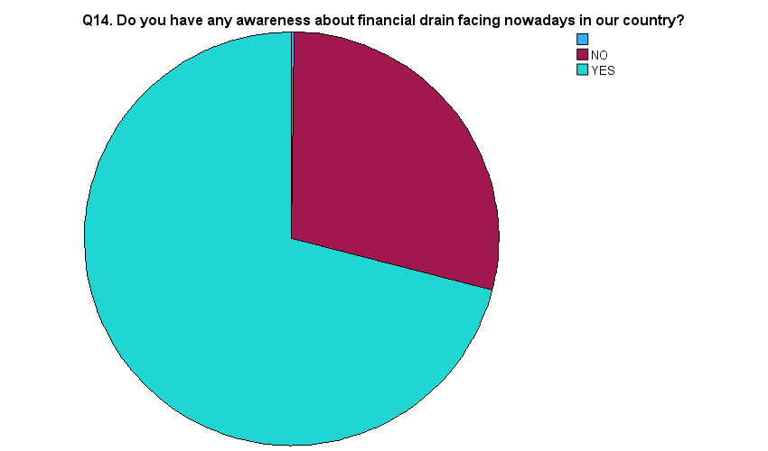

71.0 %

28.9%

|  |  |  |  |  |  |  |  |  |  |  |  |  |  |  |  |  |  |  |  |  |  |  |  |  |  |  |  |  |  |  |  |  |  |  |  |  |  |  |  |  |  |  |  |  |  |  |  |  |
| --- | --- | --- | --- | --- | --- | --- | --- | --- | --- | --- | --- | --- | --- | --- | --- | --- | --- | --- | --- | --- | --- | --- | --- | --- | --- | --- | --- | --- | --- | --- | --- | --- | --- | --- | --- | --- | --- | --- | --- | --- | --- | --- | --- | --- | --- | --- | --- | --- |
| **RESULT – ONLY 71.0 % PEOPLE ARE AWARE ABOUT THE FINANCIAL DRAIN IN INDIA**  **Analysis on using savings-**   |  |  |  |  |  |  | | --- | --- | --- | --- | --- | --- | | **Q5. If you had to make an unexpected expenditure today of 5000Rs or more would you** | | | | | | |  | | Frequency | Percent | Valid Percent | Cumulative Percent | | Valid |  | 4 | .2 | .2 | .2 | | BORROW FROM FINANCIAL INSTITUTIONS | 913 | 38.0 | 38.0 | 38.2 | | BORROW FROM FRIENDS OR RELATIVES | 215 | 9.0 | 9.0 | 47.1 | | USE SAVINGS | 1269 | 52.9 | 52.9 | 100.0 | | Total | 2401 | 100.0 | 100.0 |  |     9.0%  38.0%  52.9%  RESULT – ONLY 52.9% PEOPLE USE THEIR SAVINGS AT THE TIME OF EMERGENCY | | | | | | |  |  |  |  |
|  |  |  |  |  |  |  |  |  |  |  |
| **Analysis of expenditure**   |  |  |  |  |  |  | | --- | --- | --- | --- | --- | --- | | **Q6. Excluding any money spent on investments or the purchase of a home would you say that you are spending lavishly (unwanted purchase)** | | | | | | |  | | Frequency | Percent | Valid Percent | Cumulative Percent | | Valid |  | 4 | .2 | .2 | .2 | | Equal to income | 5 | .2 | .2 | .4 | | EQUAL TO INCOME | 879 | 36.6 | 36.6 | 37.0 | | EXCEEDED INCOME | 543 | 22.6 | 22.6 | 59.6 | | LESS THAN INCOME | 970 | 40.4 | 40.4 | 100.0 | | Total | 2401 | 100.0 | 100.0 |  |     59.6%  40.4%  36.8%  RESULT – ONLY 40.4% PEOPLE EXPAND THEIR MONEY LESS THAN THEIR INCOME |  |  |  |  |  |  |  |  |  |  |
|  |  |  |  |  |  |  |  |  |  |  |

**CHAPTER – 8RESULT AND CONCLUSION**

**RESULT-**

The survey entitled “STATISTICAL SURVEY ON FINANCIAL DRAIN IN INDIA ” was conducted in four localities of Jhansi city. It was conducted in a MCQ based format and 15 questions were asked from the audience and 2400 responses were obtained.

* RESULT- APPROXIMATELY 71.0 % PEOPLE ARE AWARE ABOUT THE FINANCIAL DRAIN IN INDIA
* RESULT- APPROXIMATELY 52.9% PEOPLE USE THEIR SAVINGS AT THE TIME OF EMERGENCY
* RESULT- APPROXIMATELY 40.4% PEOPLE EXPAND THEIR MONEY LESS THAN THEIR INCOME

**CONCLUSION-**

This final chapter assesses the evidence base for helping people to save (or save regularly), more than 60% people spend their money on unwanted things.

The more money you have saved, the more you control your own destiny. If your job has you on the verge of a nervous breakdown, you can quit, even if you don’t have a new job lined up yet, and take time off to restore your sanity before you look for new employment. If you’re tired of living in an unsafe neighborhood, you can move to a safer area because you’ll have enough for a deposit on a better apartment or a down payment on a nicer home.

If you get sick and need expensive healthcare that your insurance doesn’t cover, you’ll have a way to pay for it even though you can’t work while you’re getting treatment. And knowing that you have options because of the money you’ve socked away can give you even more peace of mind.

No, money doesn’t solve every problem. If you are laid off, it might take as long as two years to find a new job. Some illnesses won’t go away no matter how many procedures you can afford, and random crime can happen even in a supposedly secure, gated community. But with more money in the bank to deal with issues like these, you give yourself better odds of coming out on top.

Most of us put in hundreds of hours of work each year to earn most of our money. But when you have savings and stash your funds in the right places, your money starts to work for you. Over time, you’ll need to work less and less as your money works more and more, and eventually, you might be able to stop working altogether.

What does it mean to have your money working for you? When you’re first starting to save, you’ll want to put your money somewhere safe, where you can access it right away for unforeseen expenses. That means an online savings account, where you might earn 1% interest annually and not even keep up with inflation, which tends to run around 1% to 2% per year.

You’ll even have to pay taxes on your meager 1% earnings.

Anything is better than earning 0%, though, or not having savings and going into credit card debt, which will cost you 10% to 30% in interest per year.

Once you’ve saved three to six months’ worth of expenses in your emergency fund, you can start saving money in a tax-advantaged retirement account. That’s where the magic starts to happen.

In terms of interventions to promote saving, the evidence indicates there is a potentially large target audience: around half of households could be encouraged to start putting money into savings, and to save regularly; the two-thirds of households who already have money in savings could be encouraged to save more or to save regularly if they are not already doing so.

For any intervention to encourage people to save, these findings indicate that people on lower incomes and younger adults are potential target audiences. At the same time, they are likely to have less spare money and more competing demands on any money that is spare.

If they can be shown how to save without impacting their lifestyle and how to cut back on their spending, then they could be encouraged to save.

In terms of target audiences for savings interventions, an evidence gap is what distinguishes people who save from those who do not, where their personal circumstances (such as income and age) are similar. This gap might be filled by secondary analysis of large-scale datasets such as the Family Resources Survey and the Wealth and Assets Survey.

While it falls outside the remit of this evidence review, for people who hold relatively large sums of money in cash savings, there is a question about whether they should consider saving or investing their money in other ways that might produce a better return over the long-term; and what interventions might help achieve this.

**REFERENCES**

* <https://accountabilityindia.in/blog/indias-financial-drain-2/>
* <https://www.investopedia.com/articles/personal-finance/031215/why-saving-money-important.asp>
* chrome-extension://efaidnbmnnnibpcajpcglclefindmkaj/https://iopscience.iop.org/article/10.1088/1755-1315/751/1/012150/pdf
* chrome-extension://efaidnbmnnnibpcajpcglclefindmkaj/https://www.oecd.org/financial/education/oecd-infe-2020-international-survey-of-adult-financial-literacy.pdf
* <https://eduprojecttopics.com/product/statistical-analysis-of-students-expenditure-in-tertiary-institutions-a-case-study-of-imt-enugu-2004-2005-sessions/>
* https://eduprojecttopics.com/product/statistical-analysis-of-students-expenditure-in-tertiary-institutions-a-case-study-of-imt-enugu-2004-2005-sessions/